Gregorian Calendar
# Source: AI Source: Provided by: [Data Path: Persons Table -> ID Column: 1, Name_En Column: Motasem Essam] -> From: [ChatGPT] on [7/17/2026]
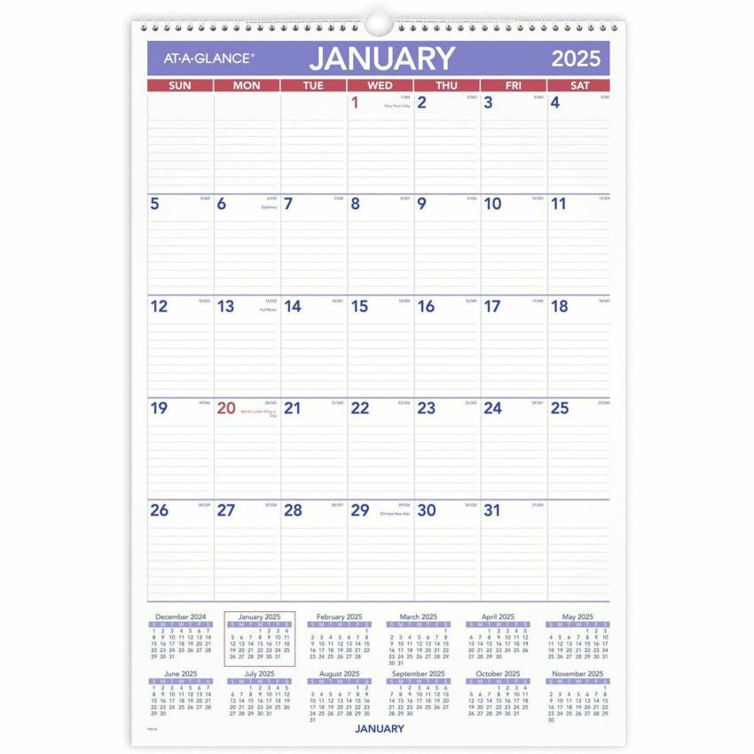

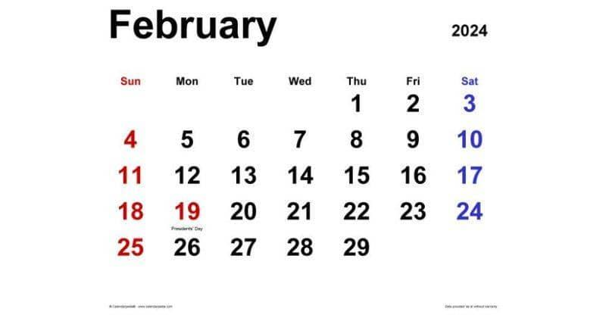

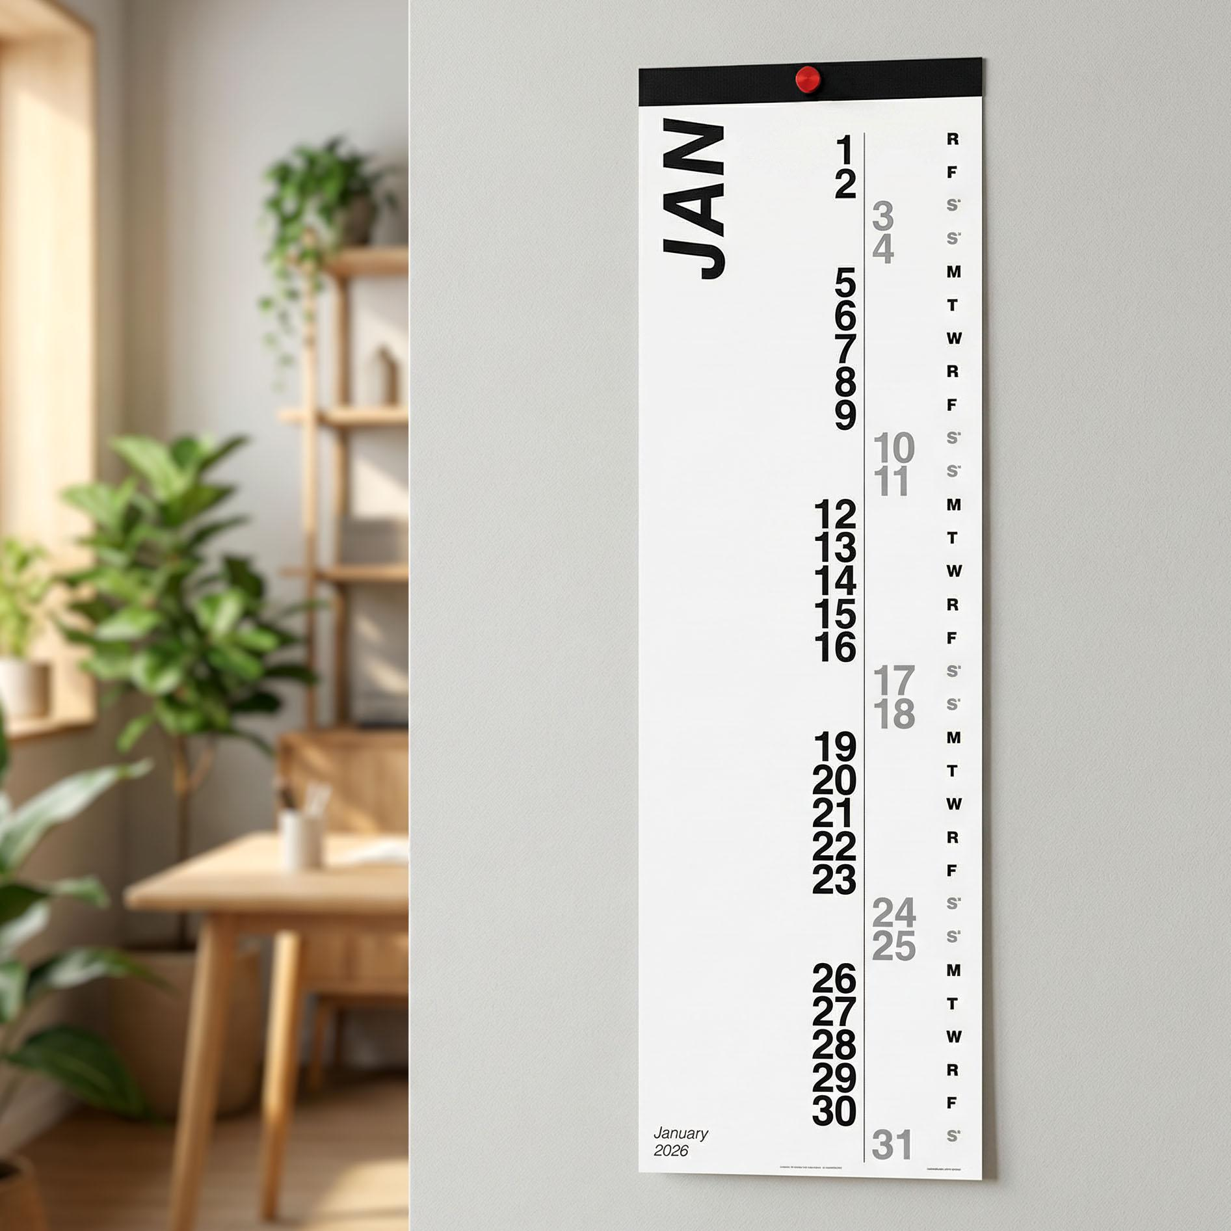
The Gregorian Calendar is the internationally accepted civil calendar used by most countries around the world. It is a solar calendar, meaning it is based on the Earth's revolution around the Sun, and it was introduced to improve the accuracy of the older Julian Calendar.
Today, the Gregorian Calendar is the standard calendar used in government, education, business, science, technology, and everyday life.

Definition
# Source: AI Source: Provided by: [Data Path: Persons Table -> ID Column: 1, Name_En Column: Motasem Essam] -> From: [ChatGPT] on [7/17/2026]
The Gregorian Calendar is a solar calendar introduced in 1582 by Pope Gregory XIII, consisting of 12 months and an average year length of approximately 365.2425 days through the use of a leap-year system.

Purpose
# Source: AI Source: Provided by: [Data Path: Persons Table -> ID Column: 1, Name_En Column: Motasem Essam] -> From: [ChatGPT] on [7/17/2026]
The Gregorian Calendar was designed to:
- Correct errors in the Julian Calendar.
- Keep the calendar aligned with the Earth's seasons.
- Determine civil dates consistently.
- Improve the calculation of important religious dates, such as Easter.
- Provide an internationally standardized calendar.

History
# Source: AI Source: Provided by: [Data Path: Persons Table -> ID Column: 1, Name_En Column: Motasem Essam] -> From: [ChatGPT] on [7/17/2026]
Creator
The calendar was introduced by:
- Pope Gregory XIII
Year Introduced
- 1582
Reason for Reform
The Julian Calendar assumed that every year was exactly 365.25 days long.
However, the actual tropical (solar) year is about:
$$365.2422\text{ days}$$
This small difference accumulated over centuries, causing the calendar to drift away from the seasons. The Gregorian reform corrected this drift and introduced a more accurate leap-year rule.

Type of Calendar
# Source: AI Source: Provided by: [Data Path: Persons Table -> ID Column: 1, Name_En Column: Motasem Essam] -> From: [ChatGPT] on [7/17/2026]
The Gregorian Calendar is a:
- Solar Calendar
It is based on:
- The Earth's revolution around the Sun.

Structure of the Gregorian Calendar
# Source: AI Source: Provided by: [Data Path: Persons Table -> ID Column: 1, Name_En Column: Motasem Essam] -> From: [ChatGPT] on [7/17/2026]
The Gregorian Calendar contains:
- 12 months
- 365 days in a common year
- 366 days in a leap year

Months of the Year
# Source: AI Source: Provided by: [Data Path: Persons Table -> ID Column: 1, Name_En Column: Motasem Essam] -> From: [ChatGPT] on [7/17/2026]
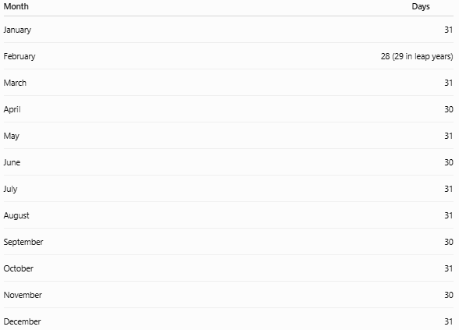
Month | Days
January | 31
February | 28 (29 in leap years)
March | 31
April | 30
May | 31
June | 30
July | 31
August | 31
September | 30
October | 31
November | 30
December | 31

Leap Year Rule
# Source: AI Source: Provided by: [Data Path: Persons Table -> ID Column: 1, Name_En Column: Motasem Essam] -> From: [ChatGPT] on [7/17/2026]
A Gregorian leap year follows these rules:
A year is a leap year if:
- It is divisible by 4.
- Except years divisible by 100 are not leap years.
- Unless they are also divisible by 400.
Examples:
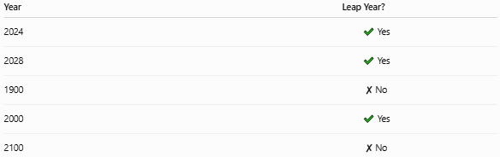
Year | Leap Year?
2024 | ✔ Yes
2028 | ✔ Yes
1900 | ✘ No
2000 | ✔ Yes
2100 | ✘ No

Average Length of the Year
# Source: AI Source: Provided by: [Data Path: Persons Table -> ID Column: 1, Name_En Column: Motasem Essam] -> From: [ChatGPT] on [7/17/2026]
The average Gregorian year is:
$$\boxed{365.2425\text{ days}}$$
This is very close to the actual tropical year of approximately 365.2422 days, making the Gregorian Calendar highly accurate for keeping the seasons aligned.

Weeks
# Source: AI Source: Provided by: [Data Path: Persons Table -> ID Column: 1, Name_En Column: Motasem Essam] -> From: [ChatGPT] on [7/17/2026]
A Gregorian week contains:
- 7 days
The days are:
- Monday
- Tuesday
- Wednesday
- Thursday
- Friday
- Saturday
- Sunday
(Some countries list Sunday as the first day of the week.)

Date Format
# Source: AI Source: Provided by: [Data Path: Persons Table -> ID Column: 1, Name_En Column: Motasem Essam] -> From: [ChatGPT] on [7/17/2026]
Common Gregorian date formats include:
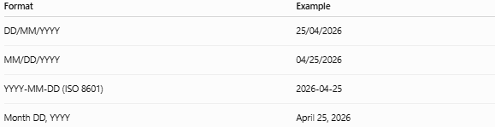
Format | Example
DD/MM/YYYY | 25/04/2026
MM/DD/YYYY | 04/25/2026
YYYY-MM-DD (ISO 8601) | 2026-04-25
Month DD, YYYY | April 25, 2026

Applications
# Source: AI Source: Provided by: [Data Path: Persons Table -> ID Column: 1, Name_En Column: Motasem Essam] -> From: [ChatGPT] on [7/17/2026]
The Gregorian Calendar is used in:
- Government
- Business
- Education
- Banking
- Healthcare
- Transportation
- Science
- Engineering
- Computing
- International communication

Advantages
# Source: AI Source: Provided by: [Data Path: Persons Table -> ID Column: 1, Name_En Column: Motasem Essam] -> From: [ChatGPT] on [7/17/2026]
The Gregorian Calendar:
- Is highly accurate.
- Keeps the seasons consistent.
- Is internationally standardized.
- Simplifies scheduling.
- Supports long-term historical records.
- Is widely accepted around the world.

Limitations
# Source: AI Source: Provided by: [Data Path: Persons Table -> ID Column: 1, Name_En Column: Motasem Essam] -> From: [ChatGPT] on [7/17/2026]
The Gregorian Calendar:
- Is not used as the primary religious calendar in all cultures.
- Does not perfectly match the tropical year (there is still a tiny error of about one day every 3,300 years).
- Requires leap-year calculations.

Comparison with the Julian Calendar
# Source: AI Source: Provided by: [Data Path: Persons Table -> ID Column: 1, Name_En Column: Motasem Essam] -> From: [ChatGPT] on [7/17/2026]
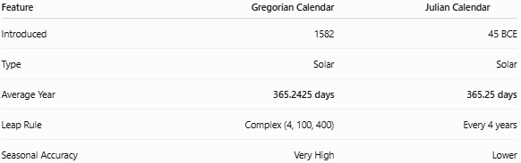
Feature | Gregorian Calendar | Julian Calendar
Introduced | 1582 | 45 BCE
Type | Solar | Solar
Average Year | 365.2425 days | 365.25 days
Leap Rule | Complex (4, 100, 400) | Every 4 years
Seasonal Accuracy | Very High | Lower

Common Uses
# Source: AI Source: Provided by: [Data Path: Persons Table -> ID Column: 1, Name_En Column: Motasem Essam] -> From: [ChatGPT] on [7/17/2026]
The Gregorian Calendar is the official calendar for:
- International organizations
- Most national governments
- Schools and universities
- Businesses
- Scientific publications
- Computer operating systems
- Internet standards

Common Mistakes
# Source: AI Source: Provided by: [Data Path: Persons Table -> ID Column: 1, Name_En Column: Motasem Essam] -> From: [ChatGPT] on [7/17/2026]
- Assuming every fourth year is a leap year (century years require special handling).
- Confusing Gregorian and Julian dates in historical records.
- Using different regional date formats without clarification (e.g., DD/MM/YYYY vs. MM/DD/YYYY).

Key Points
# Source: AI Source: Provided by: [Data Path: Persons Table -> ID Column: 1, Name_En Column: Motasem Essam] -> From: [ChatGPT] on [7/17/2026]
- The Gregorian Calendar is the world's standard civil calendar.
- It is a solar calendar introduced in 1582 by Pope Gregory XIII.
- It contains:
  - 12 months
  - 365 days in a common year
  - 366 days in a leap year
- Leap years follow the 4–100–400 rule.
- The average year length is 365.2425 days, closely matching the Earth's orbit around the Sun.

Conclusion
# Source: AI Source: Provided by: [Data Path: Persons Table -> ID Column: 1, Name_En Column: Motasem Essam] -> From: [ChatGPT] on [7/17/2026]
The Gregorian Calendar is the most widely used calendar system in the world and serves as the international standard for civil timekeeping. By combining a 12-month structure with an accurate leap-year system, it keeps the calendar closely synchronized with the Earth's seasonal cycle. Its reliability, consistency, and global acceptance make it the foundation for modern government, commerce, education, science, technology, and everyday life.

